**Practical Program of Computer Graphics**

1. **A program in c++ to move person having balloon.**

**Program:-**

#include<graphics.h>

#include<conio.h>

#include<iostream.h>

#include<DOS.h>

#include<stdlib.h>

#include<math.h>

void main()

{

int gd=DETECT,gm;

initgraph(&gm,&gd,"c:\\tc\\bgi");

int x,y,xm;

cout<<"enter x,y";

cin>>x>>y;

xm=getmaxx();

circle(x,y,50);

ellipse(x-25,y-15,0,360,3,2);

ellipse(x+25,y-15,0,360,3,2);

line(x,y-10,x,y+10);

arc(x,y+15,180,360,15);

line(x,y+50,x,y+130);

line(x,y+130,x-30,y+180);

line(x+30,y+180,x+50,y+170);

line(x,y+130,x+30,y+180);

line(x+30,y+180,x+50,y+170);

line(x,y+75,x+75,y+75);

line(x+75,y+75,x+170,y-10);

ellipse(x+170,y-50,0,360,28,40);

while(!kbhit())

{

if(x<=xm)

{

cleardevice();

x=x+20;

circle(x,y,50);

ellipse(x-25,y-15,0,360,3,2);

ellipse(x+25,y-15,0,360,3,2);

line(x,y-10,x,y+10);

arc(x,y+15,180,360,15);

line(x,y+50,x,y+130);

line(x,y+130,x-30,y+180);

line(x+30,y+180,x+50,y+170);

line(x,y+130,x+30,y+180);

line(x+30,y+180,x+50,y+170);

line(x,y+75,x+75,y+75);

line(x+75,y+75,x+170,y-10);

ellipse(x+170,y-50,0,360,28,40);

delay(100);

}

else

{

do

{

cleardevice();

x=x-20;

circle(x,y,50);

ellipse(x-25,y-15,0,360,3,2);

ellipse(x+25,y-15,0,360,3,2);

line(x,y-10,x,y+10);

arc(x,y+15,180,360,15);

line(x,y+50,x,y+130);

line(x,y+130,x-30,y+180);

line(x+30,y+180,x+50,y+170);

line(x,y+130,x+30,y+180);

line(x+30,y+180,x+50,y+170);

line(x,y+75,x+75,y+75);

line(x+75,y+75,x+170,y-10);

ellipse(x+170,y-50,0,360,28,40);

delay(100);

}

while(x!=0);

}

}

getch();

closegraph();

}

**Output:-**

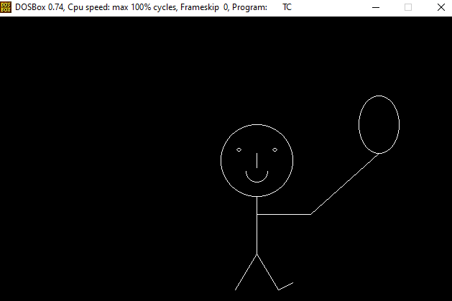

1. **A program in c++ to make a bar graph.**

**Program:-**

#include<graphics.h>

#include<conio.h>

int main()

{

int gd=DETECT,gm;

initgraph(&gd,&gm,"c:\\tc\\bgi");

int left,top,right,bottom;

bar(left=150, top=150, right=190, bottom=350);

bar(left=220, top=250, right=260, bottom=350);

bar(left=290, top=200, right=330, bottom=350);

line(100,50,100,350);

line(100,350,400,350);

getch();

closegraph();

return 0;

}

**Output:-**

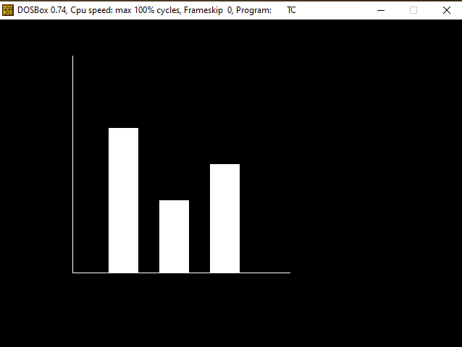

1. **A program in c++ to draws circles in circles in two different colors.**

**Program:-**

#include<graphics.h>

#include<conio.h>

#include<dos.h>

main()

{

int gd=DETECT,gm,x,y,color,angle=0;

struct arccoordstype a,b;

initgraph(&gd,&gm,"c:\\tc\\bgi");

delay(2000);

while(angle<=360)

{

outtextxy(295,240,"HACKER");

setcolor(YELLOW);

arc(getmaxx()/2,getmaxy()/2,angle,angle+2,100);

setcolor(RED);

getarccoords(&a);

circle(a.xstart,a.ystart,25);

setcolor(WHITE);

arc(getmaxx()/2,getmaxy()/2,angle,angle+2,150);

getarccoords(&a);

setcolor(GREEN);

circle(a.xstart,a.ystart,25);

angle=angle+5;

delay(50);

}

getch();

closegraph();

return 0;

}

**Output:-**

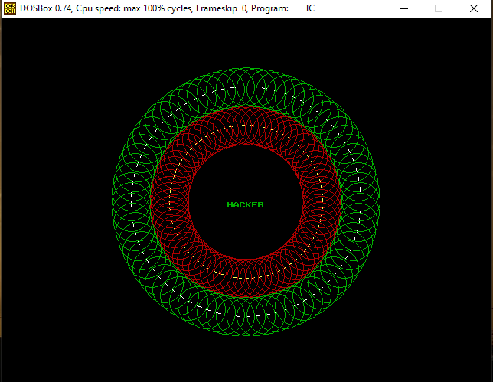

1. **A program in c++ to print an ellipse with different colors.**

**Program:-**

#include<graphics.h>

#include<iostream.h>

#include<conio.h>

void main()

{

int gd=DETECT,gm;

initgraph(&gd,&gm,"c:\\tc\\bgi");

clrscr();

setcolor(1);

ellipse(100,100,0,90,50,30);

outtextxy(100,70,"90 degree");

setcolor(2);

ellipse(100,100,90,180,50,30);

outtextxy(50,100,"180 degree");

setcolor(3);

ellipse(100,100,180,270,50,30);

outtextxy(100,150,"270 degree");

setcolor(4);

ellipse(100,100,20,360,50,30);

outtextxy(150,100,"350 degree");

setcolor(5);

line(100,50,100,150);

getch();

closegraph();

}

**Output:-**

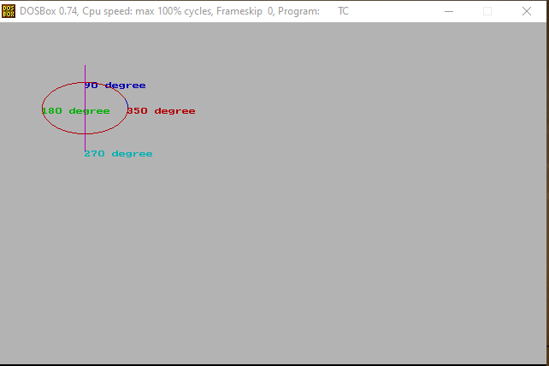

1. **A program in c++ to make a fish.**

**Program:-**

#include<graphics.h>

#include<conio.h>

#include<iostream.h>

void main()

{

int gd=DETECT,gm;

initgraph(&gd,&gm,"c:\\tc\\bgi");

ellipse(200,200,0,360,50,30);

line(250,200,280,170);

line(280,170,280,230);

line(280,230,250,200);

circle(160,190,3);

getch();

closegraph();

}

**Output:-**

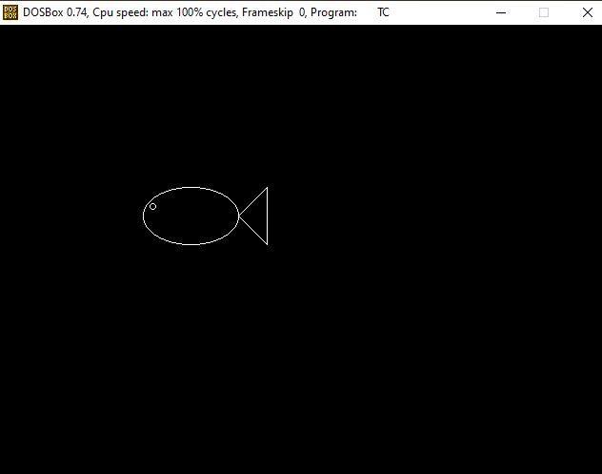

1. **A program in c++ to make a Indian Flag.**

**Program:-**

#include<stdio.h>

#include<conio.h>

#include<graphics.h>

#include<dos.h>

#include<math.h>

int main()

{

int gdriver = DETECT,gmode, a,b,i,r,x,y;

initgraph(&gdriver,&gmode,"C:\\TC\\BGI");

//draw the bottom rectangle

setfillstyle(SOLID_FILL,1);

rectangle(10,320,200,340);

floodfill(11,321,15);

rectangle(30,300,175,320);

floodfill(31,301,15);

rectangle(50,280,155,300);

floodfill(51,281,15);

//pole

setfillstyle(SOLID_FILL,3);

rectangle(100,38,110,280);

floodfill(101,39,15);

//draw the top rectangle

setfillstyle(SOLID_FILL,RED);

rectangle(110,40,220,58);

floodfill(111,43,15);

setfillstyle(SOLID_FILL,15);

rectangle(110,58,220,78);

floodfill(111,59,15);

setfillstyle(SOLID_FILL,GREEN);

rectangle(110,78,220,98);

floodfill(111,79,15);

//Ashok chakra

a=160;

b=68;

r=13;

setcolor(BLUE);

circle(a,b,r);

for(i=0;i<=360;i=i+25)

{

x=r*cos(i*3.14/180);

y=r*sin(i*3.14/180); x=r*cos(i*3.14/180); y=r*sin(i*3.14/180);

line(a,b,a+x,b-y);

}

getch();

closegraph();

return 0;

}

**Output:-**

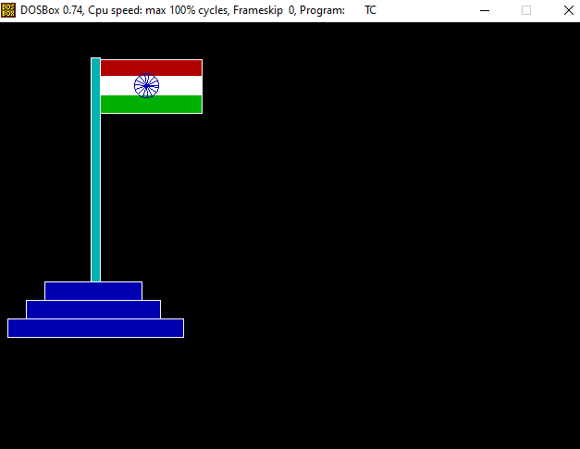

1. **A program in c++ for fundamental graphics functions.**

**Program:-**

#include<stdio.h>

#include<graphics.h>

#include<conio.h>

#include<process.h>

void main()

{

int gd=DETECT,gm,ch;

initgraph(&gd,&gm,"c:\\tc\\bgi");

{

clrscr();

printf("\nmenu\n1.circle\n2.line\n3.rectangle\n4.exit\nEnter your choice:");

scanf("%d",&ch);

cleardevice();

outtextxy(10,10,"FUNDAMENTALS");

switch(ch)

{

case 1:

circle(200,200,80);

break;

case 2:

line(200,200,300,300);

break;

case 3:

rectangle(100,100,400,400);

break;

}

getch();

closegraph();

}

}

**Output:-**

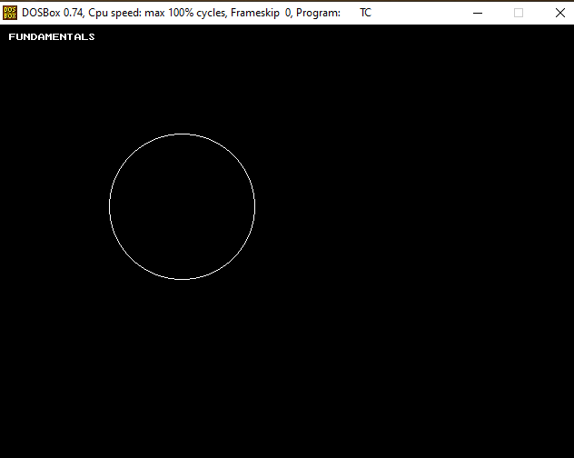

1. **A program in c++ to make a hut.**

**Program:-**

#include<graphics.h>

#include<conio.h>

#include<iostream.h>

void main()

{

int gd=DETECT,gm;

clrscr();

initgraph(&gd,&gm,"c:\\tc\\bgi");

setcolor(6);

rectangle(50,180,150,300);

rectangle(150,180,320,300);

rectangle(80,250,120,300);

line(100,100,50,180);

line(100,100,150,180);

line(100,100,300,100);

line(300,100,320,180);

getch();

closegraph();

}

**Output:-**

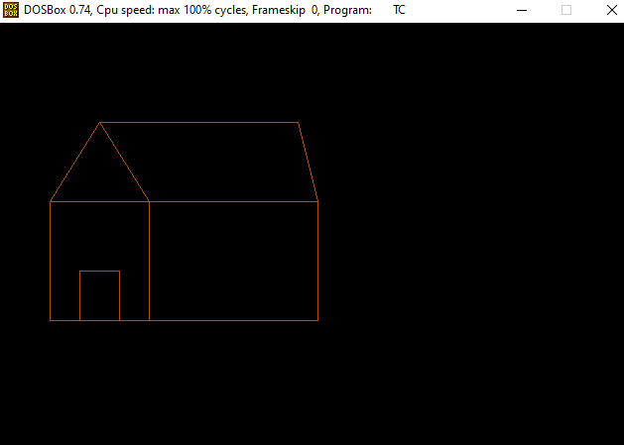

1. **A program in c++ to make a kite.**

**Program:-**

#include<graphics.h>

#include<conio.h>

#include<iostream.h>

void main()

{

int a,b,gd=DETECT,gm;

initgraph(&gd,&gm,"c:\\tc\\bgi");

line(100,100,50,180);

line(100,100,150,180);

line(50,180,100,250);

line(150,180,100,250);

line(100,100,100,250);

line(50,180,150,180);

line(100,250,70,300);

line(100,250,130,300);

line(70,300,130,300);

line(100,300,120l,320);

line(120,320,80,340);

getch();

closegraph();

}

**Output:-**

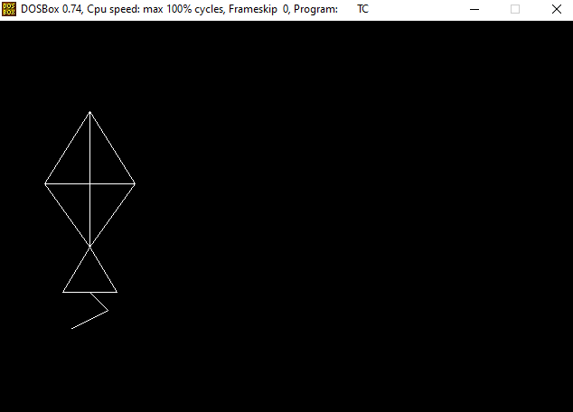

1. **A program in c++ to move a fish.**

**Program:-**

#include<graphics.h>

#include<iostream.h>

#include<conio.h>

#include<dos.h>

#include<stdlib.h>

void main()

{

int gd=DETECT,gm;

int x,y,r,c,mx,my;

initgraph(&gd,&gm,"c:\\tc\\bgi");

cout<<"enter x,y,c";

cin>>c>>y>>c;

mx=getmaxx();

my=getmaxy();

while(!kbhit())

{

if((x>=0)||(y>=my))

{

while((x>=0)||(y>0))

{

cleardevice();

setcolor(c);

ellipse(x,y,0,360,50,20);

circle(x-40,y-5,2);

line(x+50,y,x+80,y-30);

line(x+80,y-30,x+80,y+30);

line(x+80,y+30,x+50,y);

setfillstyle(1,0);

floodfill(x,y,c);

x=x-rand()%100;

y=y-rand()%100;

}

}

else

{

while((x<=mx)||(y<=my))

{

setcolor(c);

ellipse(x,y,0,360,50,20);

circle(x-40,y-5,2);

line(x+50,y,x+80,y-30);

line(x+80,y-30,x+80,y+30);

line(x+80,y+30,x+50,y);

setfillstyle(1,0);

floodfill(x,y,c);

x=x+rand()%10;

y=y+rand()%10;

}

}

delay(300);

}

getch();

closegraph();

}

**Output:-**

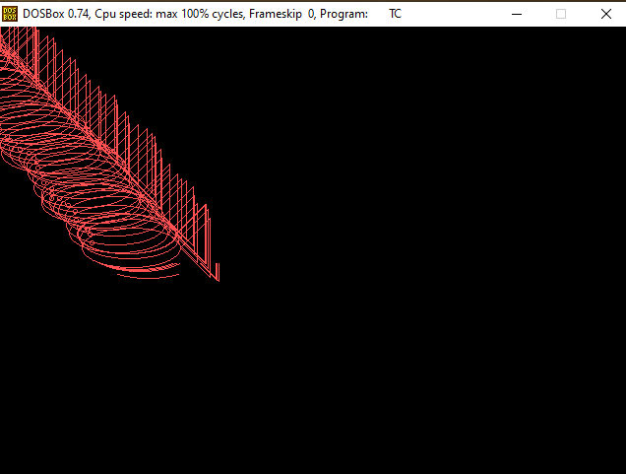

1. **A program in c++ to make a mickey.**

**Program:-**

#include<graphics.h>

#include<iostream.h>

#include<conio.h>

void main()

{

int gd=DETECT,gm;

initgraph(&gd,&gm,"c:\\tc\\bgi");

setbkcolor(0);

circle(300,220,80);

circle(250,120,30);

circle(350,120,30);

circle(340,200,10);

circle(260,200,10);

outtextxy(300,200,"|");

outtextxy(300,220,"|");

arc(300,250,180,0,20);

line(300,300,300,400);

getch();

closegraph();

}

**Output:-**

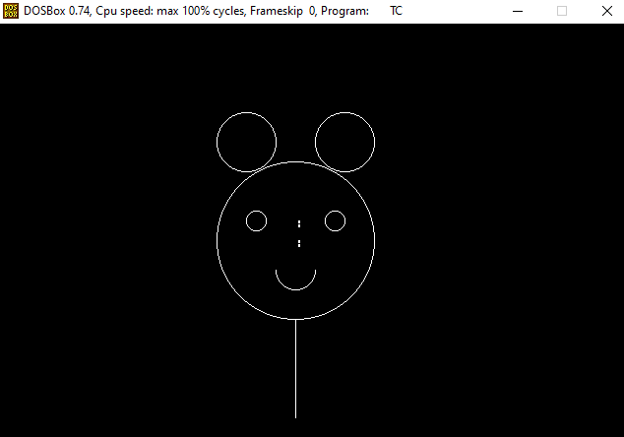

1. **A program in c++ to make a sector.**

**Program:-**

#include<iostream.h>

#include<graphics.h>

#include<stdlib.h>

#include<conio.H>

#include<stdio.h>

int main(void)

{

int gdriver=DETECT,gmode,errorcode;

int midx, midy, i;

int stangle=45,endangle=135;

int xrad=100, yrad=50;

initgraph(&gdriver,&gmode,"c:\\tc\\bgi");

errorcode=graphresult();

if(errorcode!=grOk)

{

cout<<"Graphics error: %s/n"<<grapherrormsg(errorcode);

cout<<"Press any key to halt:";

getch();

exit(1);

}

midx=getmaxx()/2;

midy=getmaxy()/2;

for(i=EMPTY_FILL; i<USER_FILL; i++)

{

setfillstyle(i, getmaxcolor());

sector(midx,midy,stangle,endangle,xrad,yrad);

getch();

}

closegraph();

return 0;

}

**Output:-**

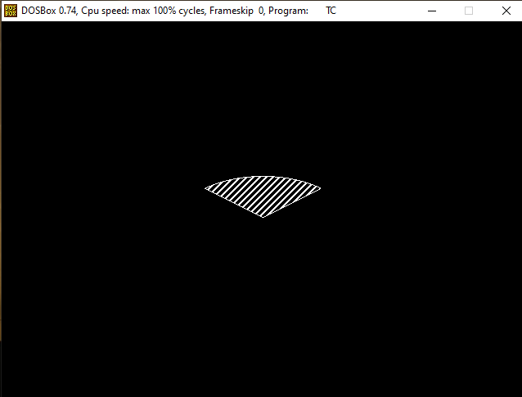

1. **A program in c++ to make a spiral.**

**Program:-**

#include<stdio.h>

#include<conio.h>

#include<graphics.h>

#include<math.h>

#include<dos.h>

#define pi 3.14159

void main()

{

int d=0,m=0;

int x,y,r,c,l;

float x1,y1,i;

clrscr();

printf("\nenter centre");

scanf("%d%d",&x,&y);

printf("nradius");

scanf("%d",&r);

printf("\ncurls");

scanf("%d",&c);

initgraph(&m,&d,"c:\\tc\\bgi");

l=360*c;

for(i=0;i<l; i++)

{

x1=x+r*i/l*cos(i*pi/180);

y1=y+r*i/l*sin(i*pi/180);

putpixel(x1,y1,i/6);

delay(5);

}

getch();

closegraph();

}

**Output:-**

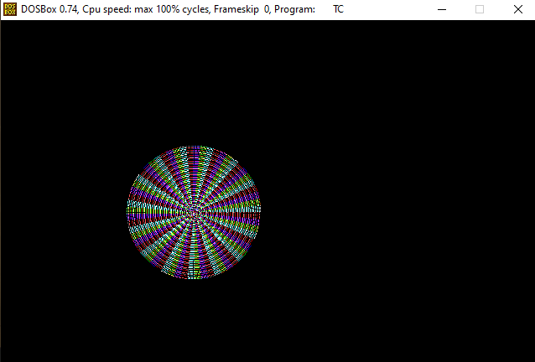

1. **A program in c++ to draw space with stars.**

**Program:-**

#include<graphics.h>

#include<stdlib.h>

#include<conio.h>

void main()

{

int gd=DETECT,gm;

int i,x,y;

initgraph(&gd,&gm,"c:\\tc\\bgi");

line(0,0,640,0);

line(0,0,0,480);

line(639,0,639,480);

line(639,479,0,479);

for(i=0;i<=3500;i++)

{

x=rand()%639;

y=rand()%480;

putpixel(x,y,15);

}

getch();

closegraph();

}

**Output:-**

